# Open garage Band – You will need a mouse

Layer Mute

Sound Loop Screens

Sound Loop Type

* Select the Application Folder
* 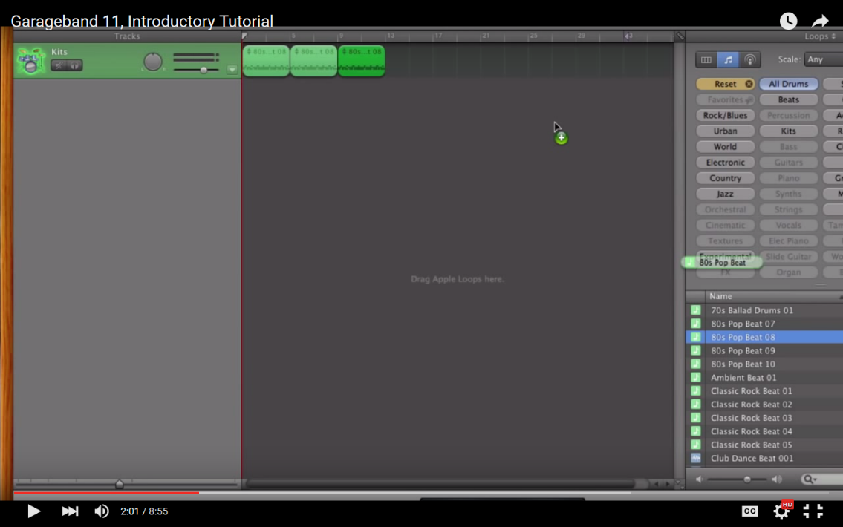Select Garage Band
* Select Continue/New Design
* Select New Project/Empty Project
* Select the Microphone & Create
* 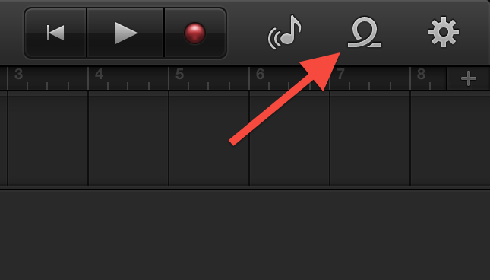Select **LOOPS (right side)**
* Save As: **Practice Ad First Name hour**
* Where: **Your H drive**

Right Side: Add Sound loops in layers

* Select Type: Ex: Acoustic Guaitar, Electric, or both!
* Add sound loops – drag on
* After music created, select voice to record voice layer

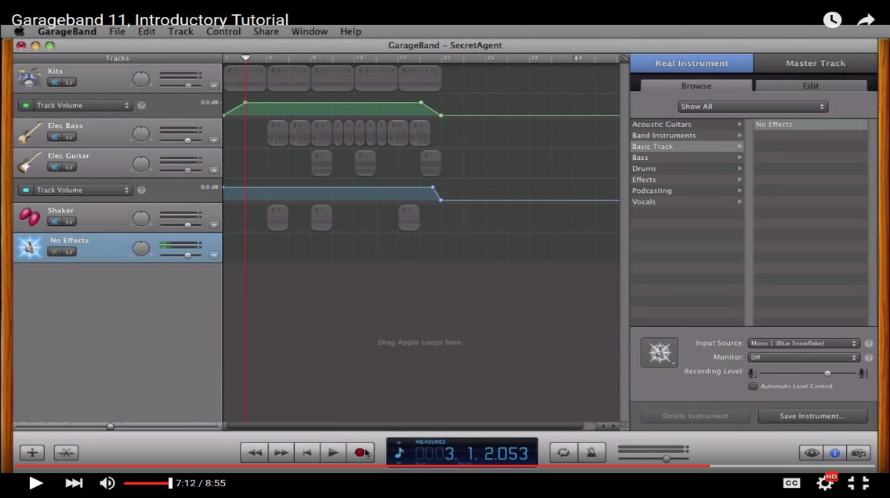Add additional loops/separate layer

* Select **Reset**
* Select **Beats**
* Drag onto a new layer

Sound Options

Top Screen Play  
Record

Shorten/Lengthen a Loop

* Double Click – drag right or left

Record your Voice (your voice should be louder than all other layers)

View Loop Browser   
(first option must be on)

* Select the **+ Sign** on the upper left corner above your first layer
* Select **The Microphone**
* Select **Create**
* Another Layer is added – Mute all background music layers
  + Select **Mute** **Button** On Each layer (don’t record your voice with background playing)
* Select **Record (top red button)** to record voice and stop when done recording
* Move Voice track to start shortly after the music

**Save as an MP3 File**

* Select Share
* Select Export Song to Disk
* Compress Using: MP3 Coder
* Audio Settings: “Highest Quality”
* Select Export
* Save as = Practice Ad Name Hour (your group assignment is Radio Ad John & Stacy 7th)
* Where = Your H drive
* Drag and drop this into the inbox for your hour
* Play to preview

Change your Voice

* Select **Voice** on Right
* Select **types of vocal (ex: bright, classic, Dance etc)**
* Select and try a few different effects (be careful it   
  does not sound unprofessional)

Review and Rework if needed:

* **Turn on all sound layers** and play to hear all together
* 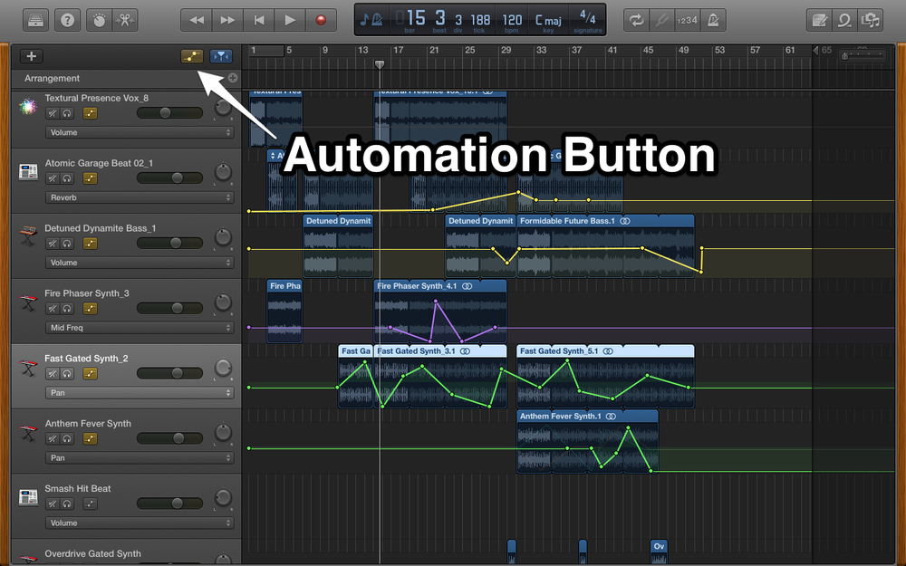Use Fade in and Out (symbol to the right of the + icon).

Fade in/out so starts lower and gets louder.